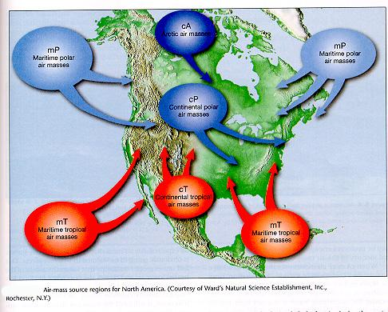
Air Masses Over North America
COLD AIR MASSES
Most of the cold winter weather in the United States comes from three polar air masses.
- Continental polar (cP) air masses form over northern Canada. They bring
extremely cold winter weather. In the summer, cP air masses can bring cool, dry weather.
- Maritime polar (mP) air masses form over the North Pacific Ocean. They are cool and very wet. They bring rain and snow to the Pacific Coast in winter. They bring fog in the summer. Maritime polar air masses also form over the North Atlantic Ocean. They bring cool, cloudy weather and precipitation to New England.

WARM AIR MASSES
Four warm air masses influence the weather in the United States.
- Maritime tropical (mT) air masses form over warm areas in the Pacific Ocean, the Gulf of Mexico, and the Atlantic Ocean. They move across the East Coast
and into the Midwest. In summer they bring heat, humidity, hurricanes, and thunderstorms to these areas.
- Continental tropical air masses (cT) form over deserts and move northward. They bring clear, dry, hot weather in the summer.
What Are Fronts?
The place where two or more air masses meet is called a front. When air masses meet, the less dense air mass rises over the denser air mass. Warm air is less dense than cold air. Therefore, a warm air mass will generally rise above a cold air mass. There are four main kinds of fronts: cold fronts, warm fronts, occluded fronts, and stationary fronts.

COLD FRONTS
A cold front forms when a cold air mass moves under a warm air mass. The cold air pushes the warm air mass up. The cold air mass replaces the warm air mass. Cold
fronts can move quickly and bring heavy precipitation. When a cold front has passed, the weather is usually cooler. This is because a cold, dry air mass moves in
behind the cold front.
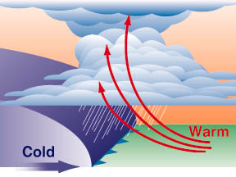

A cold front forms
when a cold air mass
pushes a warmer air
mass away. The front
moves in the direction
that the cold air
mass is moving.

WARM FRONTS
A warm front forms when a warm air mass moves in over a cold air mass that is leaving an area. The warm air replaces the cold air as the cold air moves away. Warm fronts can bring light rain. They are followed by clear, warm weather.

A warm front forms
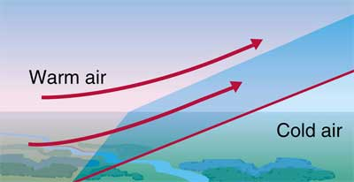
when a warm air mass
moves in and replaces
a cold air mass. The
front moves in the
direction the warm air
mass is moving

OCCLUDED FRONTS
An occluded front forms when a warm air mass is caught between two cold air masses. Occluded fronts bring cool temperatures and large amounts of rain and snow.
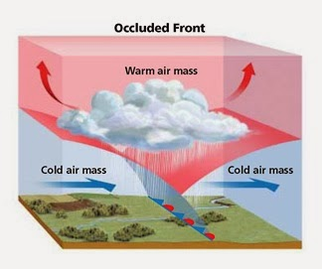
An occluded front
forms when a warm
air mass is trapped
between two cold air
masses. The cold air
masses move together
and push the warm air
out of the way.

STATIONARY FRONT
A stationary front forms when a cold air mass and a warm air mass move toward each other. Neither air mass has enough energy to push the other out of the way.
Therefore, the two air masses remain in the same place. Stationary fronts cause many days of cloudy, wet weather.
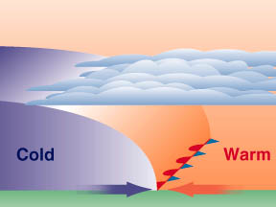
A stationary front forms
when air masses stay in
one place.

