Dynamic Earth Study Guide
___Plate______ ___Tectonics________________ the theory that explains how large pieces of Earth’s __crust moves___________
__Transform______________ Boundary  The boundary between two tectonic plates that are ___sliding______________  ___past____________ each other laterally  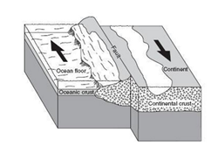 | ___Divergent______________ Boundary  The boundary between two tectonic plates that are __moving away__________ ____________  from each other.  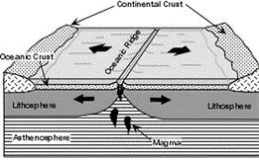 | ___Convergent______________ Boundary  The boundary between two tectonic plates that collide____________ or __subduct__________ (move under) the other.  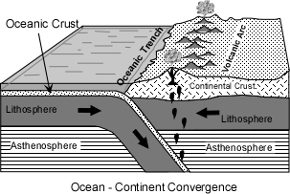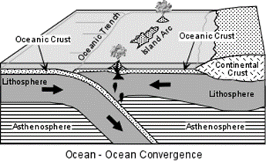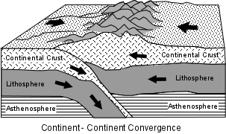  Continental – oceanic: more dense _tectonic________ plate________ _subducts_________ under continental crust.  Oceanic – oceanic: more ___dense________ (older) crust __subducts___________ under the less dense (_younger_________) crust.  Continental – continental: more dense___________ (older) crust ___subducts__________ under the less dense (___younger_______) crust.
What is formed:  -Earthquakes | What is formed:  On land: rift valleys  In ocean: sea-floor spreading; mid ocean ridges | What is formed:  Continental – oceanic: Volcanoes, Earthquakes, Trenches  Oceanic – oceanic: Volcanic islands arcs, trenches, earthquakes  Continental – continental: Mountains
Where is one located:  - San Andreas Fault  - | Where is one located:  -Middle of Atlantic Ocean  - | Where is it located:  Continental – oceanic: Mount St. Helens  Oceanic – oceanic: Hawaii  Continental – continental: Himalaya Mountains

Label the layers of Earth, after identifying which layers are chemical and physical.
_______Chemical____________________ Layers: _____Physical ___________________________ Layers:
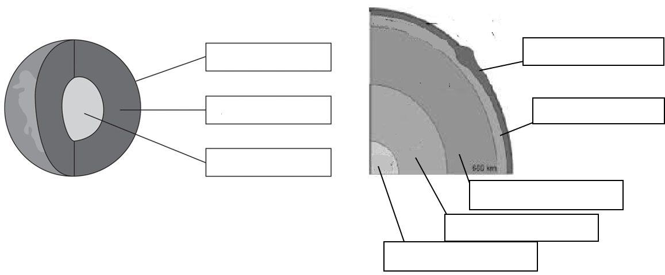
Inner Core
Outer Core
Mesosphere
Asthenosphere
Lithosphere
Core
Mantle
Crust

