1. Complete the Venn diagram comparing heliocentric and geocentric models.
Include: philosophers, organization of planets and celestial objects.

2. Complete a descriptive sketch below and label all the celestial objects in each model.
Heliocentric Geocentric

3. Give 2 pieces of evidence to support each model:
a. Geocentric model
1).__________________________________________________________________________________
2). __________________________________________________________________________________
b. Heliocentric model
1). ___________________________________________________________________________________
2). ___________________________________________________________________________________

4. Explain what the Big Bang theory states and what it created?
a. States…. __________________________________________________________________________
__________________________________________________________________________________________
b. Created…__________________________________________________________________________
__________________________________________________________________________________________

5. Label the following:
a. Name of our galaxy
b. Type of galaxy
c. 2 major arms
d. Name the arm our solar system is located on
e. Use an X to mark the general location of
our solar system

6. Label the following according to size.
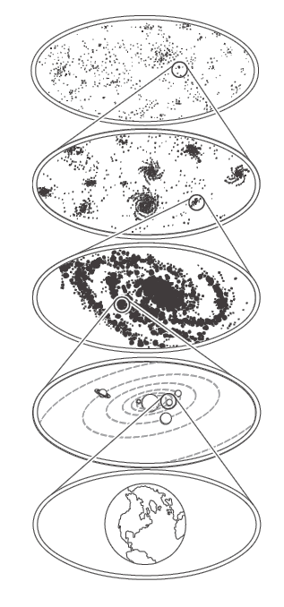
Word bank: galaxy, planet, universe, galaxy cluster, solar system

