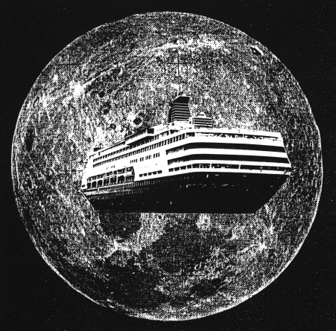

You have just acquired a job with Solar System Cruise Lines, the #1 luxury celestial line! People from all over the world are booking travel with your company. The only problem is that they don’t know nearly as much as you do about the solar system. Your boss is so impressed with your knowledge, she has put you in charge! Your job is to create a brochure / book / travel guide that gives planet specifics to cruise guests. You must include statistics of each planet:
- Include atmosphere features of each planet
  - Compare the atmosphere of Mars and the Earth
  - Compare the atmosphere of Jupiter and Neptune
2. Size of the planet (diameter in km)
3. How does the size of that planet compare to Earth’s size (give comparisons decimals or percentages).
4. Distance of planet from the sun (in AU)
5. Planet surface features
a. How is the landscape of Venus different from the landscape of Earth?
6. Ability to support life
a. Why can or can’t life exist on the planet.
In addition, because vacationing families want to get the most for their money, you must also include:
1. Three (3) FUN facts about the planet – A must see for vacationing families that has NOT been listed in other sections.
2. Labeled and illustrated picture of the planet
3. On the front cover, illustrate the only planet that can support life AND
give 3 reasons why it can support life

Remember to design a neat and organized brochure because you’re selling the trip of a lifetime!

Rubric
CATEGORY | 4 | 3 | 2 | 1
Planet Illustrations | All 8 planets are illustrated and labeled correctly. | 7- 6 planets are illustrated and labeled correctly. | 5 - 4 planets are illustrated and labeled correctly. | Less than 4 planets are illustrated and labeled correctly.
Atmospheric Features | All 8 planets have the correct atmospheric features represented. | 7 - 6 planets have the correct atmospheric features represented. | 5 - 4 planets have the correct atmospheric features represented. | Less than 4 planets have the correct atmospheric features represented.
Size of Planet in km | All 8 planets have the correct size represented. | 7 – 6 planets have the correct size represented. | 5 - 4 planets have the correct size represented. | Less than 4 planets have the correct size represented.
Size Compared to Earth | All 8 planets have the appropriate representation of the planet size compared to the relative size of Earth. | 7 - 6 planets have the appropriate representation of the planet size compared to the relative size of Earth. | 5 - 4 planets have the appropriate representation of the planet size compared to the relative size of Earth. | Less than 4 planets have the appropriate representation of the planet size compared to the relative size of Earth.
Distance from Sun in AU | All 8 planets have the correct distance from the sun represented. | 7 - 6 planets have the correct distance from the sun represented. | 5 - 4 planets have the correct distance from the sun represented. | Less than 4 planets have the correct distance from the sun represented.
Surface Features | All 8 planets have the correct surface features represented. | 7 - 6 planets have the correct surface features represented. | 5 - 4 planets have the correct surface features represented. | Less than 4 planets have the correct surface features represented.
Ability to Support Life | All 8 planets have a justified reason why it can or cannot support life. | 7 - 6 planets have a justified reason why it can or cannot support life. | 5 - 4 planets have a justified reason why it can or cannot support life. | Less than 4 planets have a justified reason why it can or cannot support life.
Interesting Facts (all planets except Earth) | 7 planets have interesting or fun facts listed. | 6 - 5 planets have interesting or fun facts listed. | 4 - 3 planets have interesting or fun facts listed. | Less than 3 planets have interesting or fun facts listed.
Earth | 3 reasons why Earth can support life and Earth is placed in correct location of brochure. | 2 reasons why Earth can support life and Earth is placed in correct location of brochure. | 1 reason why Earth can support life and Earth is placed in correct location of brochure. | No reasons why Earth can support life and Earth is placed in correct location of brochure.
Additional compare and contrast questions (1A, 1B, 5A) | All 3 additional questions are answered correctly. | 2 additional questions are answered correctly. | 1 additional questions are answered correctly. | None of the additional questions are answered correctly.
Attractiveness | Project is exceptionally attractive in terms of design, layout and neatness. | Project is attractive in terms of design, layout and neatness. | Project is acceptably attractive in terms of design, layout and neatness. | Project is distractedly messy or very poorly designed and hard to read.

