AIR MASSES AND FRONTS (pg.490-494)
Changes in ___weather______________ are caused by the movement and interaction of air masses.
An ___air mass______________ a large body of air where temperature and moisture content are similar throughout.
The __moisture ____________________ content and ___temperature_____________ of an air mass are determined by the areas ______source regions____________________ (where it forms
4 Types of masses (how do they form):
Maritime (m) __forms over water; wet__ Continental (c): _forms over land; dry __________
Tropical (T)__forms over tropic; warm___ Polar (P): _forms over the polar regions; cold
What weather will they bring?
North pacific: cool; wet; rain, snow, fog in summer. North Atlantic: cool, cloudy, rain, foggy in summer
Maritime Polar (mP) :_______________________________________________________
Maritime Tropical (mT): summer: hot, humid, hurricanes; winter: mild cloudy weather __________________________________________________
Continental Polar (cP): __extremely cold, dry weather___________________
Continental Tropical (cT):_clear dry hot weather__________________________________
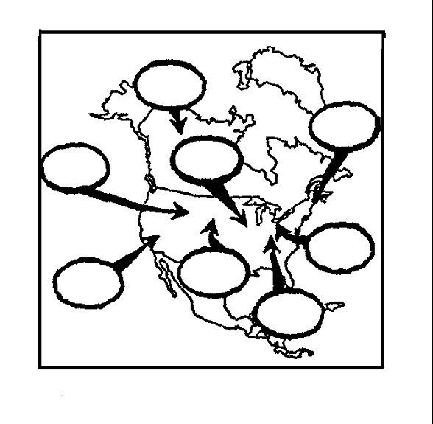
dry; warm
cold dry
hot; humid, hurricanes, cloudy
mP
cool, wet, rain
mP
mT
mT
cT
cP
mT
mP
- Use the air mass symbols to label the chart to the right.
- Also describe what kind of weather each air mass would bring.
Where do the masses Originate? Name the Air Mass, 2-letter symbol, and origin
Air Masses | Origins
Maritime Tropical (mT) | Gulf of Mexico, Atlantic and Pacific Oceans
Continental Tropical (__cT____) | Northern Mexico, Southwstern US
Maritime Polar (___mP______) | Northern Atlantic or Pacific
Continental Polar(cP) | North Alaska and Canada
Complete the Graphic Organizer. Illustrate the front by labeling warm air mass, cold air mass, AND drawing arrows showing the movement of warm and cold air.
Warm Front:
- Forms: warm air mass moves over cold(denser) air
- Moves:_gradually to replace cold air
- Brings: drizzly rain followed by clear warm weather
- Symbol:
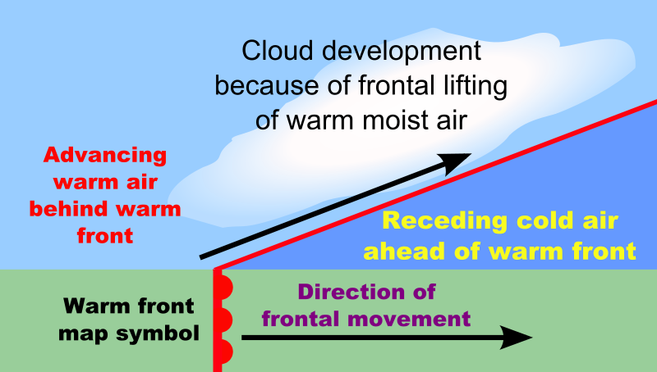

- Illustration:

Cold Front:
- Forms:_cold air moves under warm air pushing warm air up ____
- Moves:_quickly_______________
- Brings:_ thunderstorms, heavy rain or snow_________________________
- Symbol: Arrows face direction front is moving
- Illustration: 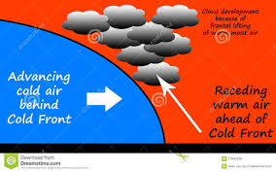

Illustration:

Stationary Front:
- Forms:_cold air mass meets warm air mass with same force
- Moves:__very little movement; no force
- Brings:_days of cloudy wet weather
- Symbol:
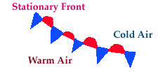
- Illustration:

Occluded Front:
- Forms:_warm air is caught between 2 colder air masses
- Moves:_cold air moves under warm air; coldest air sinks warm air moves up
- Brings: cool temperatures; large amounts of rain and snow
- Symbol: Icy and sunny

- Illustration:

air mass. The second letter represents the temperature that is characteristic of the air mass.
