_____________________ ___________________ Convergent Boundary

**Label** the boundaries below. Complete the illustrations by **adding arrows** to show plate movement, **label type of crust**, and **features created**.

Name: ______________________

Period: ______________________

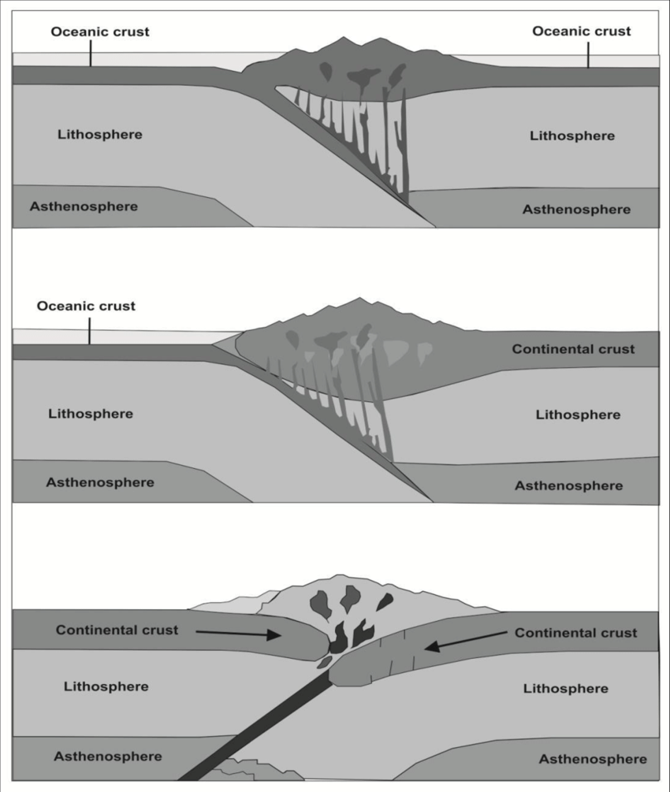

________________ Crust

_________________ Crust

__________________________

_________________________

___________________ Crust

_________________________

__________________ Crust

_________________________

_________________________ ________________________ Convergent Boundary

_________________________ ________________________ Convergent Boundary

_________________________

_________________________

_________________________

_________________________

__________________ Crust

___________________ Crust

_____________________ Boundary

**Label** the boundaries below. Complete the illustrations by **adding arrows** to show plate movement, **label type of crust**, and **features created**.

Name: ______________________

Period: ______________________

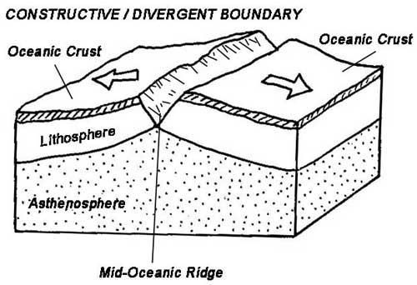

___________________________

______________ Crust

____________________ Crust

_____________________ Boundary

_______________________

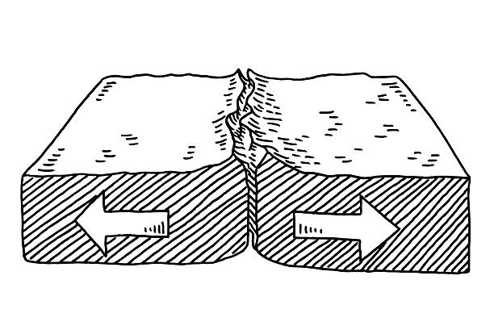

_____________________ Boundary

_______________ Crust

_______________Crust

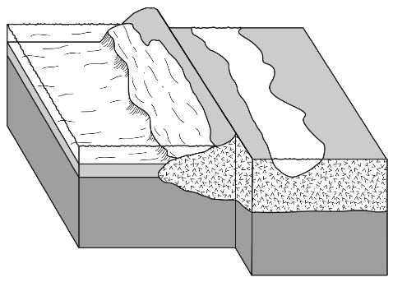

_____________________ ___________________

_______________ Crust

_______________ Crust