Deforestation is the permanent destruction of forests in order to make the land available for other uses. An estimated 18 million acres (7.3 million hectares) of forest, which is roughly the size of the country of Panama, are lost each year, according to the United Nations' Food and Agriculture Organization (FAO).
Some other statistics:
- About half of the world's tropical forests have been cleared, according to the FAO.
- Forests currently cover about 30 percent of the world’s landmass, according to National Geographic.
- The Earth loses 18.7 million acres of forests per year, which is equal to 27 soccer fields every minute, according to the World Wildlife Fund (WWF).
- It is estimated that 15 percent of all greenhouse gas emissions come from deforestation, according to the WWF.
- In 2016, global tree cover loss reached a record of 73.4 million acres (29.7 million hectares), according to the University of Maryland.

Location

Deforestation occurs around the world, though tropical rainforests are particularly targeted. If current deforestation levels proceed, the world's rainforests may completely vanish in as little as 100 years, according to National Geographic. Countries with significant deforestation in 2016 included Brazil, Indonesia, Thailand, the Democratic Republic of Congo and other parts of Africa, and parts of Eastern Europe, according to GRID-Arendal, a United Nations Environment Program collaborating center. The country with the most deforestation is Indonesia. Since the last century, Indonesia has lost at least 39 million acres (15.79 million hectares) of forest land, according to a study by the University of Maryland and the World Resource Institute.
Though deforestation has increased rapidly in the past 50 years, it has been practiced throughout history. For example, 90 percent of continental United States' indigenous forest has been removed since 1600, according to the University of Michigan. The World Resources Institute estimates that most of the world's remaining indigenous forest is located in Canada, Alaska, Russia and the Northwestern Amazon basin.

Causes
There are many causes of deforestation. The WWF& reports that half of the trees illegally removed from forests are used as fuel.
Some other common reasons are:
- To make more land available for housing and urbanization
- To harvest timber to create commercial items such as paper, furniture and homes
- To create ingredients that are highly prized consumer items, such as the oil from palm trees
- To create room for cattle ranching
Common methods of deforestation are burning trees and clear cutting. These tactics leave the land completely barren and are controversial practices.
Clear cutting is when large swaths of land are cut down all at once. A forestry expert quoted by the Natural Resources Defense Council describes clear cutting as "an ecological trauma that has no precedent in nature except for a major volcanic eruption."
Burning can be done quickly, in vast swaths of land, or more slowly with the slash-and-burn technique. Slash and burn agriculture entails cutting down a patch of trees, burning them and growing crops on the land. The ash from the burned trees provides some nourishment for the plants and the land is weed-free from the burning. When the soil becomes less nourishing and weeds begin to reappear over years of use, the farmers move on to a new patch of land and begin the process again.

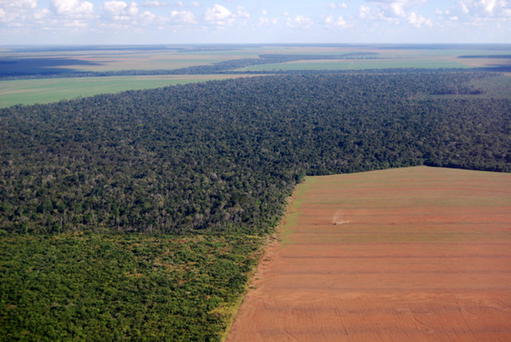
Deforestation in Brazil: Aerial view of a large soy field eating into the tropical rainforest.
Credit: Frontpage Shutterstock

Deforestation and climate change
Deforestation is considered to be one of the contributing factors to global climate change. According to Michael Daley, an associate professor of environmental science at Lasell College in Newton, Massachusetts, the No. 1 problem caused by deforestation is the impact on the global carbon cycle. Gas molecules that absorb thermal infrared radiation are called greenhouse gases. If greenhouse gases are in large enough quantity, they can force climate change, according to Daley. While oxygen (O₂) is the second most abundant gas in our atmosphere, it does not absorb thermal infrared radiation, as greenhouse gases do. Carbon dioxide (CO₂) is the most prevalent greenhouse gas. CO₂ accounts for about 82.2 percent of all U.S. greenhouse gas, according to the Environmental Protection Agency (EPA). Trees can help, though. About 300 billion tons of carbon, 40 times the annual greenhouse gas emissions from fossil fuels, is stored in trees, according to Greenpeace.
The deforestation of trees not only lessens the amount of carbon stored, it also releases carbon dioxide into the air. This is because when trees die, they release the stored carbon. According to the 2010 Global Forest Resources Assessment, deforestation releases nearly a billion tons of carbon into the atmosphere per year, though the numbers are not as high as the ones recorded in the previous decade. Deforestation is the second largest anthropogenic (human-caused) source of carbon dioxide to the atmosphere(after fossil fuel combustion), ranging between 6 percent and 17 percent, according to a study published in 2009 in Nature.
Carbon isn't the only greenhouse gas that is affected by deforestation. Water vapor is also considered a greenhouse gas. "The impact of deforestation on the exchange of water vapor and carbon dioxide between the atmosphere and the terrestrial land surface is the biggest concern with regard to the climate system," said Daley. Changes in their atmospheric concentration will have a direct effect on climate.
Deforestation has decreased global vapor flows from land by 4 percent, according to an article published by the journal National Academy of Sciences. Even this slight change in vapor flows can disrupt natural weather patterns and change current climate models.

Other effects of deforestation
Forests are complex ecosystems that affect almost every species on the planet. When they are degraded, it can set off a devastating chain of events both locally and around the world.
Loss of species: Seventy percent of the world's plants and animals live in forests and are losing their habitats to deforestation, according to National Geographic. Loss of habitat can lead to species extinction. It also has negative consequences for medicinal research and local populations that rely on the animals and plants in the forests for hunting and medicine.
Water cycle: Trees are important to the water cycle. They absorb rain fall and produce water vapor that is released into the atmosphere. Trees also lessen the pollution in water, according to the North Carolina State University, by stopping polluted runoff. In the Amazon, more than half the water in the ecosystem is held within the plants, according to the National Geographic Society.
Soil erosion: Tree roots anchor the soil. Without trees, the soil is free to wash or blow away, which can lead to vegetation growth problems. The WWF states that scientists estimate that a third of the world's arable land has been lost to deforestation since 1960. After a clear cutting, cash crops like coffee, soy and palm oil are planted. Planting these types of trees can cause further soil erosion because their roots cannot hold onto the soil. "The situation in Haiti compared to the Dominican Republic is a great example of the important role forests play in the water cycle," Daley said. Both countries share the same island, but Haiti has much less forest cover than the Dominican Republic. As a result, Haiti has endured more extreme soil erosion, flooding and landslide issues.
Life quality: Soil erosion can also lead to silt entering the lakes, streams and other water sources. This can decrease local water quality and contribute to poor health in populations in the area.
The disturbance of native people: Many native tribes live in the rainforests of the world, and their destruction is the destruction of these peoples' homes and way of life. For example, the film "Under the Canopy" takes a look at the Amazon rainforest and the people who live there, including an indigenous guide named Kamanja Panashekung. "Kamanja's community is one of over 350 indigenous communities throughout Amazonia that depend on the rainforest, as we all do, for the air we breathe and the water we drink," M. Sanjayan, Conservation International's executive vice president and senior scientist, said in a statement. [Explore the Amazon Rainforest with New Virtual-Reality Film]

Counteracting deforestation
Many believe that to counter deforestation, people simply need to plant more trees. Though a massive replanting effort would help to alleviate the problems deforestation caused, it would not solve them all.
Reforestation would facilitate:
- Restoring the ecosystem services provided by forests including carbon storage, water cycling and wildlife habitat
- Reducing the buildup of carbon dioxide in the atmosphere
- Rebuilding wildlife habitats
Reforestation won't completely fix the damage, though. For example, Daley points out that forests cannot sequester all of the carbon dioxide humans are emitting to the atmosphere through the burning of fossil fuels and a reduction in fossil fuel emissions. It is still necessary to avoid buildup in the atmosphere. Reforestation will not help with extinction due to deforestation, either. "Unfortunately, we have already diminished the population of many species to such an extreme that they might not recover, even with a massive reforestation effort," Daley told Live Science.
In addition to reforestation, some other tactics are being taken to counteract or slow deforestation. Some of them include shifting the human population to a plant-based diet. This would lower the need for land to be cleared for raising livestock.
Global Forest Watch has also initiated a project to counteract deforestation through awareness. The organization uses satellite technology, open data and crowdsourcing to detect and alert others of deforestation. Their online community is also encouraged to share their personal experiences and the negative effects of deforestation.
Additional reporting by Alina Bradford and Jessie Szalay, Live Science contributors

