Inner Core

Composition: _____________________________

Temperature: ____________________________

Thickness: ________________________________

Density: ___________________________________

The Inner core is different than all the other layers because:

The Inner Core is SOLID because:

Trip Highlights

This is what happens to temperature, density, and pressure as you go from
the crust to the core?

Although we cannot go into the earth, we know what is inside because:

A Trip to the Center of the Earth
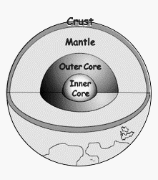

Take a trip, a fantastic voyage to the earth’s center, where you will be able to compare and contrast the 4 fabulous layers of the Earth while discovering the amazing composition, temperature, and density of the earth layers.

Name ________________________________ Period _____

Crust

Composition: _____________________________

Temperature: ____________________________

Thickness: ________________________________

Density: __________________________________

The Crust and the ________________
are most similar because:

The Crust and the ________________
are different because:

The Crust is different than all the other layers because the Crust:

Mantle

Composition: _____________________________

Temperature: ____________________________

Thickness: ________________________________

Density: __________________________________

The Mantle and the ________________
are most similar because:

The Mantle and the ________________
are different because:

The Mantle is different than all the other layers because:

Outer Core

Composition: _____________________________

Temperature: ____________________________

Thickness: ________________________________

Density: __________________________________

The Outer Core and the ________________
are most similar because:

The Outer Core and the ________________
are different because:

The Outer core is different than all the other layers because:

