- You come into the building from the bus port area and notice a lot of water along the walkway. Later in the day, you look out the window of the chorus / orchestra rooms and see the water is gone. 1. Why did the puddle appear? 2. What has happened to the water?
1. _________________________________________________________________________________________
2. _________________________________________________________________________________________
- Think back to the models you made. What where the water cycle processes you observed and why did they happen?
What did you observe? | What was the water cycle process? | Why did it happen?
- Fill in the missing word in the numbered box. Complete a brief description the process in the table.
11 __________
- What are 2 differences in lakes and oceans: _________________________ _________________________ Give examples of:
Salt Water | 1. _______________________________  2. ________________________________
Fresh water | 1. _________________________________  2. _________________________________  3. _________________________________

- Complete the graph below that describes the distribution of water on earth. Please include a percentage.

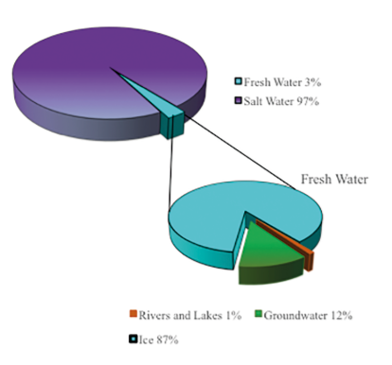

This represents ALL earths’ water.

This represents all earths’ FRESH water.

14. About how much of the earth is land? _______________________________
15. About how much of the earth is water? ______________________________
16. What makes the ocean salty? ____________________________________________________________________

17. View the picture and answer the following questions:
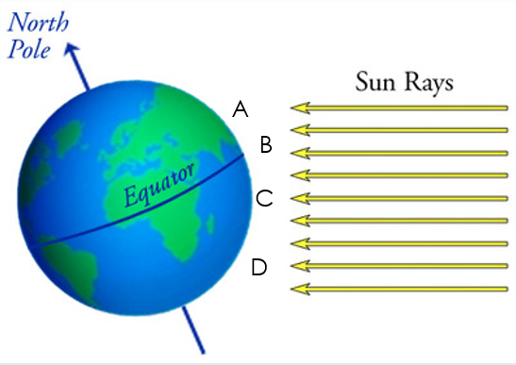
a. Where would the most evaporation occur? _______
b. What increases as a result of this evaporation or freezing?
____________________________________________
c. How does water with high salinity move compared
to water with low salinity? ______________________
____________________________________________
d. What does the density of seawater depend on?
____________________________________________
18. Why does the water on earth remain the same? Justify your answer.
________________________________________________________________________________________________
________________________________________________________________________________________________
________________________________________________________________________________________________
19. What are the 2 regions of the ocean? ________________________________ & ____________________________
20. Label the diagram below and give a brief description of the feature.
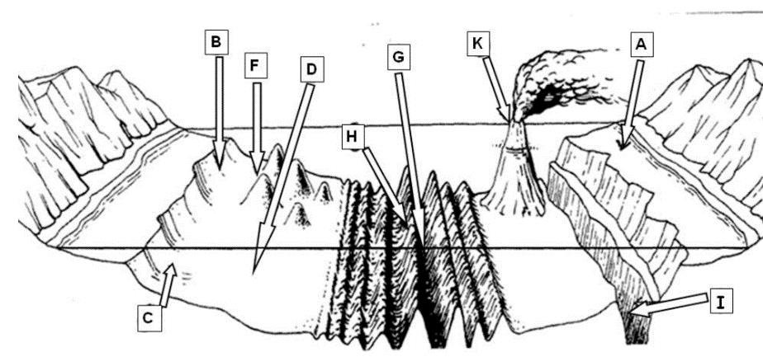
A | D | G
B | E | H
C | F | I

