- You come into the building from the bus port area and notice a lot of water along the walkway. Later in the day, you look out the window of the chorus / orchestra rooms and see the water is gone. 1. Why did the puddle appear? 2. What has happened to the water?
1. The puddle appeared due to precipitation and runoff. Precipitation is any form of water that falls to Earth’s surface from the clouds. Runoff is water that flows over land, it always flows downhill towards oceans, lakes, and marshlands.
2. The water has disappeared due to evaporation. Evaporation occurs when liquid water turns into water vapor.
- Think back to the models you made. What where the water cycle processes you observed and why did they happen?
What did you observe? | What was the water cycle process? | Why did it happen?
Steam leaving the boiling pot of water | Evaporation | The hot plate (energy source) changed the liquid water to water vapor.
Liquid water appearing on the lid of the pot of boiling water | Condensation | The water vapor changed back to liquid water when it cooled off on the lid.
Liquid water falling back into the pot of boiling water | Precipitation | Once enough water condensed on the lid, gravity forced the water droplets to fall back into the pot
- Fill in the missing word in the numbered box. Complete a brief description of the process in the table.
1. Precipitation- any form of water that falls to Earth from clouds
2. Sublimation- solid water changes to water vapor
3. Precipitation - any form of water that falls to Earth from clouds
4.Condensation- change of state from gas to liquid
5.Evaporation- when liquid water changes state to water vapor
6.Infiltration- when water on land seeps into the ground
7.Runoff- water on Earth’s surface that flows downhill
8.Accumulation- when water collects on Earth’s surface
9.Groundwater-water that has infiltrated Earth’s surface and is underground. It flows downhill through soil & rock
10.Transpiration- plant sweat, plants release water vapor
11.Energy Source- provides the energy for water cycle
11 __________
- What are 2 differences in lakes and oceans: Amount of salinity, Density of Water, Temperature of Water
- Give examples of:
Salt Water | 1. ___Oceans____________________________  2. ____Seas____________________________
Fresh water | 1. __Lakes_______________________________  2. _____Ground Water____________________________  3. _____Frozen Fresh Water_____

- Complete the graph below that describes the distribution of water on earth. Please include a percentage.
Saltwater – 97.5% (Oceans)
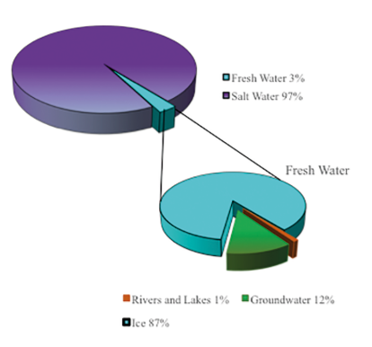
Freshwater – 2.5%
This represents ALL earths’ water.
This freshwater is both frozen and liquid

Ice Caps & Glaciers – 79%

This represents all earths’ FRESH water.
Groundwater – 20%

Freshwater Available – 1% (this is lakes, rivers, water vapor in atmosphere, water in living things)

14. About how much of the earth is land? _____30%__________________________
15. About how much of the earth is water? ___70%___________________________
16. What makes the ocean salty? __Dissolved salts from water flowing on or under Earth’s surface. The water carries calcium, magnesium, and sodium ions from rocks into the oceans.

17. View the picture and answer the following questions:
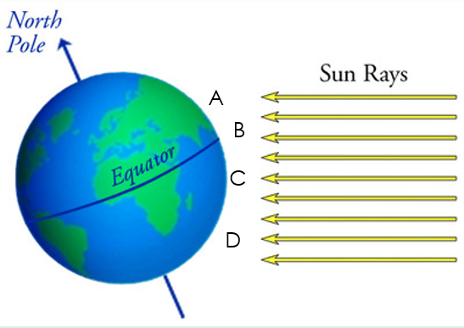
a. Where would the most evaporation occur? B – evaporation
occurs most near the equator
b. What increases as a result of this evaporation or freezing?
____The salinity in liquid water increases when water
Evaporates or freezes.
c. How does water with high salinity move compared
to water with low salinity? ______Water with high salinity sinks,
it is more dense.
d. What does the density of seawater depend on?
____The density of seawater depends on salinity and temperature.
18. Why does the water on earth remain the same? Justify your answer.
The water on earth remains the same because water moves on earth through a cycle. It is not created or destroyed, it just changes state between frozen, liquid, and vapor. Water on earth changes location between the surface (Ocean, lakes, rivers, aquifers, ice caps, glaciers, water in living things) the ground (groundwater, aquifers) and the atmosphere.
19. What are the 2 regions of the ocean? __Continental Margin__ & ____Deep Ocean Basin_
20. Label the diagram below and give a brief description of the feature.
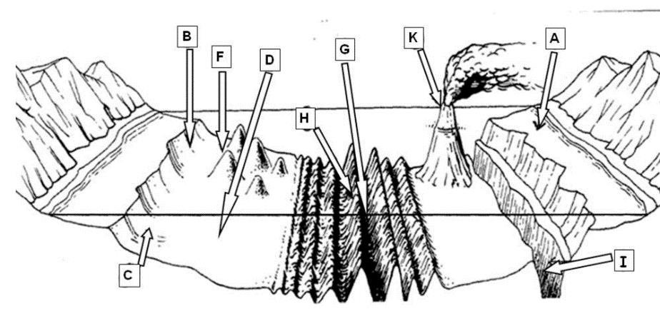
- Continental Shelf- flat underwater extension of the continent | D Abyssal Plains – flat area of deep ocean basin, covered in sediment | G Trench -A long narrow depression in the ocean basin
B Continental Slope- Steep slope off the continental shelf | K – Volcanic Island – seamount has grown above sea level and the magma from the volcano has emerged to form an island | H Mid Ocean Ridge – long undersea mountain chain
C Continental Rise – gently sloping terrain into the Deep Ocean Basin | F Seamounts – submerged volcanic islands on the ocean floor where hot magma rises | I Trench -A long narrow depression in the ocean basin

