List and Define Key Terms: 3) Who proposed continental drift in the late 1800s?
(write in your own words) _________________________________________________________________
1) Pangea: 4) What two pieces of evidence support the movement of continents?
1. _________________________________________________________
2. _________________________________________________________
What discovery found at the bottom of the ocean supported plate tectonics? ___________________________________________________________
2) Sea Floor spreading: 5) What three discoveries support continental drift? Explain the findings.
1. _______________________________________________________________
_________________________________________________________________
2. _______________________________________________________________
7) Plate Tectonics: 3. _______________________________________________________________
6) What are two types of earth’s crust and where are they located?
1.________________________________________________________________
2. _______________________________________________________________
9) Which type of tectonic plate is most dense? ___________________________
10) Which type of tectonic plate is thickest? _____________________________
8) Tectonic plates: 11) What are three types of plate boundaries? 1.______________________________________________
2. ______________________________________________
3. ______________________________________________
12) Molten (melted) rock INSIDE the earth is called ? __________________
13) Molten (melted) rock OUTSIDE the earth is called? ____________________
14) Divergent Boundary: 15) Label the diagram below using ARROWS to show direction of plate movement.
What does this boundary form?
1. ________________________
2. ________________________
3. ________________________
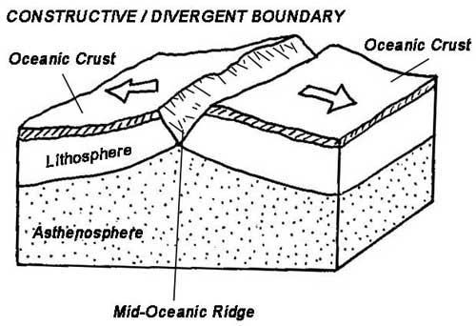

16) Transform Boundary: 18) Label the diagram below using ARROWS to show direction of plate movement
What is felt at this boundary?
__________________________
What is a famous boundary in the USA?
__________________________
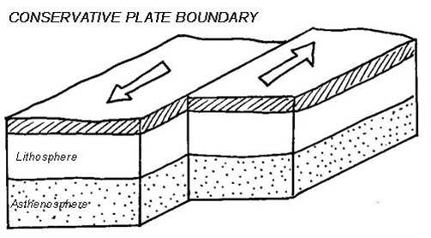

17) Convergent Boundary: 19) What are the 3 types of convergent boundaries?
1. _________________________________________
2. __________________________________________
3. __________________________________________

20) What crust will subduct and why?
21) Convection: _________________________________________________________________

24) Label the diagrams below using ARROWS to show direction of plate movement.
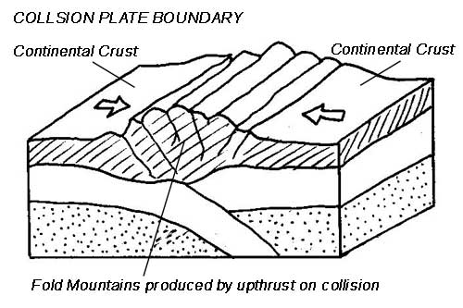
Name of this collision:
__________________________
What does this collision create?
__________________________

22) Ridge Push:

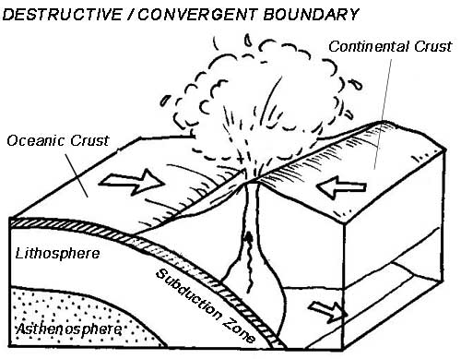
Name of this collision:
__________________________
What does this collision create?
1. ________________________
2. ________________________
25)

23) Slab Pull:

26)
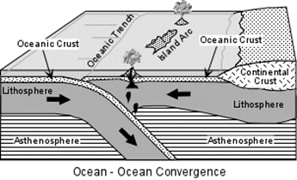
Name of this collision:
__________________________
What does this collision create?
1. ________________________
2. ________________________

