List and Define Key Terms: Who proposed continental drift in the late 1800s?
(write in your own words) _________________________________________________________________
Pangea: What two pieces of evidence support the movement of continents?
1. _________________________________________________________
2. _________________________________________________________
What discovery found at the bottom of the ocean supported plate tectonics? ___________________________________________________________
Sea Floor spreading: What three discoveries support continental drift? Explain the findings.
1. _______________________________________________________________
_________________________________________________________________
2. _______________________________________________________________
Plate Tectonics: 3. _______________________________________________________________
What are two types of earth’s crust and where are they located?
1.________________________________________________________________
2. _______________________________________________________________
Which type of tectonic plate is most dense? ______________________________
Which type of tectonic plate is thickest? _________________________________
Tectonic plates: What are three types of plate boundaries? 1.______________________________________________
2. ______________________________________________
3. ______________________________________________
Molten (melted) rock INSIDE the earth is called __________________________
Molten (melted) rock OUTSIDE the earth is called? _______________________
Divergent Boundary: Label the diagram below using ARROWS to show direction of plate movement.
What does this boundary form?
1. ________________________
2. ________________________
3. ________________________
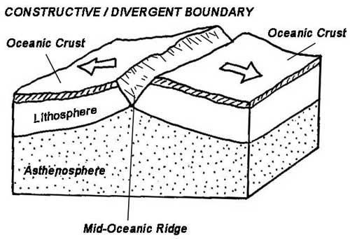

Transform Boundary: Label the diagram below using ARROWS to show direction of plate movement.
What is felt at this boundary?
__________________________
What is a famous boundary in the USA?
__________________________
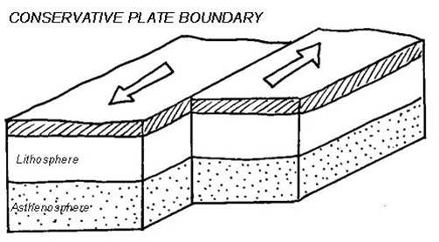

Convergent Boundary: What are the 3 types of convergent boundaries?
1. _________________________________________
2. __________________________________________
3. __________________________________________

What crust will subduct and why?
Convection: _________________________________________________________________

Label the diagrams below using ARROWS to show direction of plate movement.
Name of this collision:
__________________________
What does this collision create?
__________________________
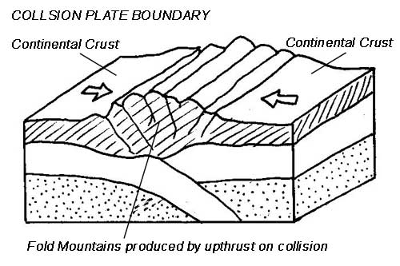

Ridge Push:

Name of this collision:
__________________________
What does this collision create?
1. ________________________
2. ________________________
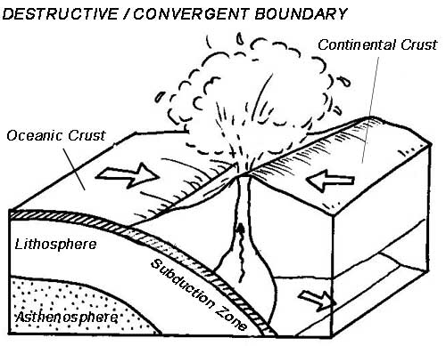

Slab Pull:

Name of this collision:
__________________________
What does this collision create?
1. ________________________
2. ________________________
