Name_______________________________________ Date_______________ Period_________

Opening Activity:

Students:
- Make a close inspection of the materials that we will use during today’s lab activity.
  - colored pencils or crayons
  - cup of water
  - pipette (water dropper) or a cotton ball
  - skittles (1 per student is sufficient)
  - tin pan/paper plate (shallow container of any kind will suffice)

Students:
- After collecting all your materials, answer the following question in step or sequence format.

  - How are we going to use the materials listed above?

1.

2.

3.

4.

5.

  - What concepts do you THINK 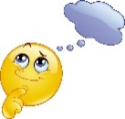we are trying to demonstrate/master?

__________________________________________________________________

Name _____________________________________ Period ____________

Skittles Lab:
Hypothesis: “If I drop water on the skittle, then ____________________will happen.

_________________________________________________________________________________________________________________________________________________________________________________.
Directions:
    - Use the pipette (water dropper) or a cotton ball to squeeze 10 drops of water onto your skittle from a distance of roughly 6 inches.
    - Record your results in visual format. (draw what it looks like in the box below using colored pencils or crayons)
    - Record your results in written format (describe what is happening).
    - Repeat steps 2 and 3 after 20, 30, 40, and 50 drops.

10 Drops 20 Drops 30 Drops 40 Drops 50 Drops

Visuals

Written

*After you have completed your drawings and written details above, watch the “Best Science Teachers Ever” video (on blog and here is the link: https://youtu.be/damMbdy5j8Y ) and compare and contrast the differences in the video and what you did with the skittle/skittles. Include EVERYTHING you noticed in the video and EVERYTHING you noticed doing the skittles activity. Also, include in your Venn diagram what were the similarities and differences in both activities.

Comparing and Contrasting Activities
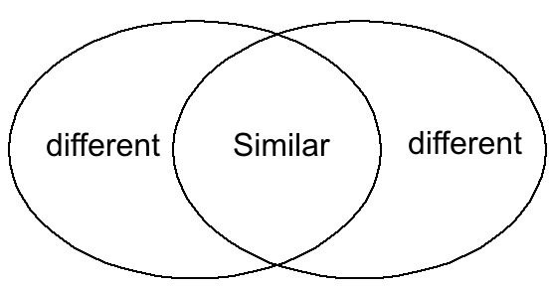

Best Science Teachers video
Skittles Activity

