Control of Soil Erosion

Methods farmers use to slow-down or stop run-a-way soil:
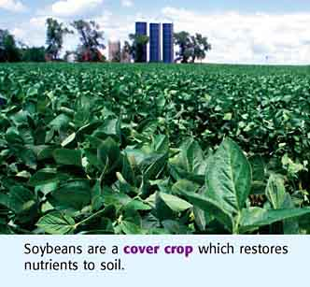
- Cover crops:
Another method to stop soil erosion is to plant crops that will grow during the most erosive fall and spring months. Winter cover crops such as fall rye or winter wheat act as a ground cover and protect the vulnerable soil from eroding.

- Contour plowing/cultivation:
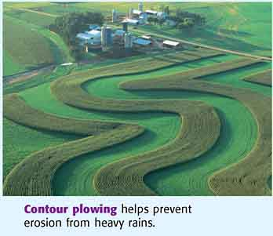
Cultivation is the process of loosening up the soil between the rows of a growing crop. Some farmers plant and cultivate their crops to follow the contours of a field. Contour cultivation produces furrows that are perpendicular or at an angle to the slope of the field. The irregular surface of the field breaks up the flow of water and makes it more difficult for water to erode the soil.

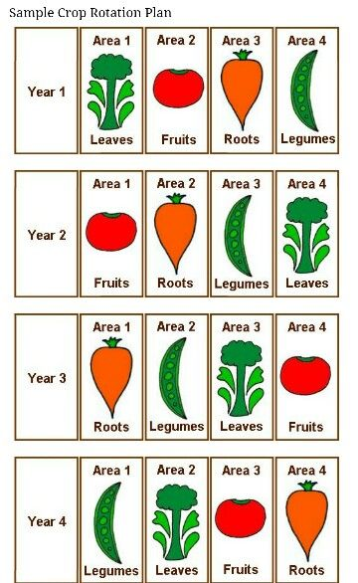

- Crop in rotation:
Forage crops such as alfalfa and hay can be included
in a rotation to cut down on erosion. In areas where the
land has steep terrain the practice of strip cropping forage
crops and crops such as corn or wheat is a common way to
slow erosion.

4. Conservation tillage:
If farmers leave the soil bare after they harvest a crop, they are asking for trouble! Most farmers today will practice conservation tillage where they leave stalks and leaves of the harvested crops on their fields. This layer protects the underlying soil from wind and rain during the fall and winter until a new crop is planted in the spring. One kind of conservation tillage is chisel-plowing which mixes crop residue into the soil. This leaves the ground partially covered from the wind and rain. Below you will find descriptions for two common types of conservation tillage practices. There are other methods that farmers use too, though!
5. No till:
No-till farming means that farmers leave all of the last crop's residue in the soil while planting the new crop.
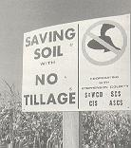  A road sign promotes  no-till farming. Agriculture  and the Environment, 1991  Yearbook: 38 |  |  | 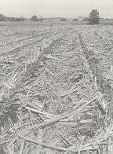  Soybeans growing in corn  residue with no-till farming.  Agriculture and the Environment,  1991 Yearbook: 17
6. Ridge Tilling  Farmers may use special machinery to form the soil into ridges and then plant the seeds on top of the ridges. The soil and residue from the previous crop between the ridges are not disturbed during planting and cultivation. Since this plant and soil material is not broken loose by the machinery, it is less likely to erode. |  | 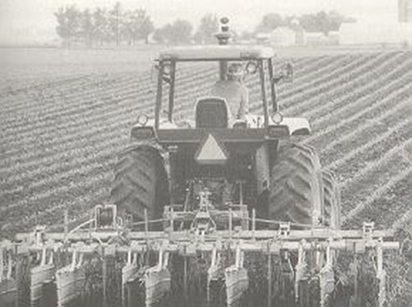  A farmer cultivates his field with a special plow used for ridge tilling. Agriculture and the Environment, 1991 Yearbook: 183

7.Terracing:
On extremely steep slopes, farmers often alter the shape of the land by building a series of terraces, which prevent the water from running down the steep slope and provide more surface area for farming. Terracing is considered a costly investment because it takes time to build up the slopes and uses expensive resources like concrete.
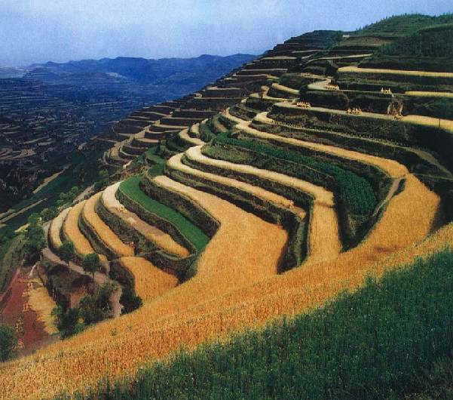
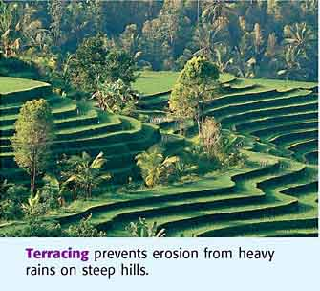

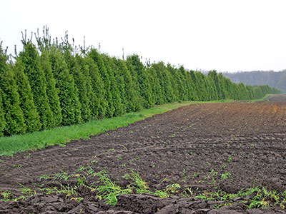
8. Windbreaks
Some farmers plant trees along the borders of their fields to cut down on wind erosion. This method is most often practiced in flat areas but is useful in hilly regions as well.

9. Grassed waterways: In some fields the landforms natural depressions where run-off water goes. To keep the soil in these depressions from running away with the water, farmers plant grassy strips. Excess water is absorbed by the grass rather than acting as an erosion agent.
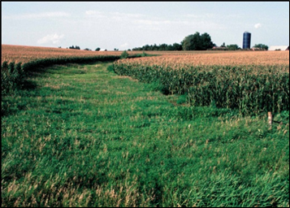
10. Strip Cropping - Farmers may decide to alternate a field with strips of different crops or fallow. Strip cropping may be used in flat areas, but it also is a kind of contour farming when strips are planted across the slope of a field.
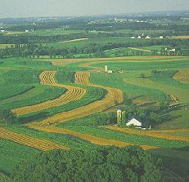

Soil Properties
Some soils are great for growing plants. Other soils can’t support the growth of plants. 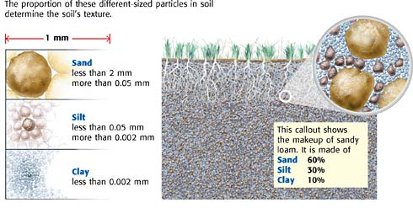
To better understand soil, you will next learn about its properties, such as soil texture, soil structure, and soil fertility.
Soil Texture and Soil Structure
Soil is made of different-sized particles. These particles can be as large as 2 mm, such as sand. Other particles can be too small to see without a microscope. Soil texture is the soil quality that is based on the proportions of soil particles
Soil texture affects the soil’s consistency. Consistency describes a soil’s ability to be worked and broken up for farming. For example, soil texture that has a large proportion of clay can be hard and difficult for farmers to break up. Soil texture influences the infiltration, or ability of water to move through soil. Soil should allow water to get to the plants’ roots without causing the soil to be completely saturated.
Water and air movement through soil is also influenced by soil structure. Soil structure is the arrangement of soil particles. Soil particles are not always evenly spread out. Often, one type of soil particle will clump in an area. A clump of one type of soil can either block water flow or help water flow, which affects soil moisture.

Soil Fertility
Nutrients in soil, such as iron, are necessary for plants to grow. Some soils are rich in nutrients. Other soils may not have many nutrients or are not able to supply the nutrients to the plants. A soil’s ability to hold nutrients and to supply nutrients to a plant is described as soil fertility. Many nutrients in soil come from the parent rock. Other nutrients come from humus, which is the organic material formed in soil from the decayed remains of plants and animals. These remains are broken down into nutrients by decomposers, such as bacteria and fungi.
Soil Horizons
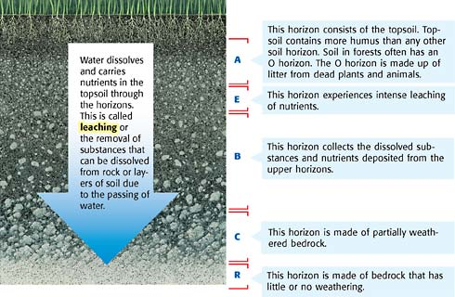
Because of the way soil forms, soil often ends up in a series of
layers, With humus-rich soil on top, sediment below that, and
bedrock on the bottom. Geologists call these layers horizons.
The word horizon tells you that the layers are horizontal. You
can see these layers in some road cuts. The top layer of soil is
often called the topsoil. Topsoil contains more humus than the
layers below it. The humus is rich in the nutrients plants need
to be healthy. This is why good topsoil is necessary for farming.

Soil pH
Soils can be acidic or basic. The pH scale is used to measure how acidic or basic a soil is and ranges from 0 to 14. The midpoint, which is 7, is neutral. Soil that has a pH below 7 is acidic. Soil that has a pH above 7 is basic.
The pH of a soil influences how nutrients dissolve in the soil. For example, plants are unable to take up certain nutrients from soils that are basic, or that have a high pH. Soils that have a low pH can restrict other important nutrients from hungry plants. Because different plants need different nutrients, the right pH for a soil depends on the plants growing in it.
Soil and Climate
Soil types vary from place to place. One reason for this is the differences in climate. As you read on, you will see that climate can make a difference in the types of soils that develop around the world.
Tropical Rain Forest Climates
In tropical rain forest climates, the air is very humid and the land receives a large amount of rain. Because of warm temperatures, crops can be grown year-round. The warm soil temperature also allows dead plants and animals to decay easily. This provides rich humus to the soil.
Because of the lush plant growth, you may think that tropical rain forest soils are the most nutrient-rich in the world. However, tropical rain forest soils are nutrient poor. The heavy rains in this climate leach precious nutrients from the topsoil into deeper layers of soil. The result is that tropical topsoil is very thin. Another reason tropical rain forest soil is nutrient poor is that the lush vegetation has a great demand for nutrients. The nutrients that aren’t leached away are quickly taken up by plants and trees that live off the soil.

