- Define Continental Drift:

- What is Pangaea?

- How is fossil and rock formation evidence used to provide evidence of Pangaea? Describe discussing the image.
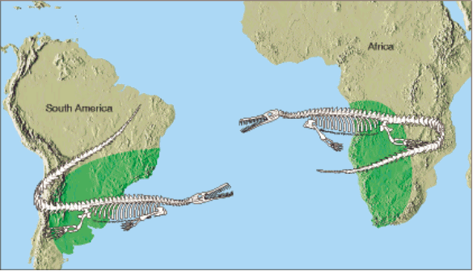
- Define the Theory of Plate Tectonics:

- What are two pieces of evidence that support the theory of plate tectonics?

- Circle the correct answers, increases or decreases: As depth increases / decreases density, temperature, and pressure increases / decreases.

- What is the difference between the physical and chemical layers of Earth?

- What are similarities and differences between the crust and the lithosphere?

- Describe Asthenosphere. Describe the Mesosphere.

- What causes the tectonic plates to move? Describe how that process works.

- What is the difference between oceanic crust and continental crust?

- Compare and Contrast the Inner and Outer Core.

Name of layer ->
Temperature | ºC | 3,000-4,000 ºC | ___________ºC | 0-1,000 ºC
Density |  |  |  | Least Dense
Composition | Iron and Nickel
Physical Properties |  |  | Semi-solid molten rock
Thickness | km | 2,200 km | km | 5-70 km

Free Space Below! - Write or draw anything else you remember about Earth’s Layers, Continental Drift, or Tectonic Plate!

