- Define Continental Drift:
The proposed idea from Alfred Wegner in 1800 that stated the continents were drifting away from each other

- What is Pangaea?
245 million years ago the continents were joined in a single land mass
- How is fossil and rock formation evidence used to provide evidence of Pangaea? Describe discussing the image.
Fossils of the same species were found on 2 different continents because those 2 continents were once connected.
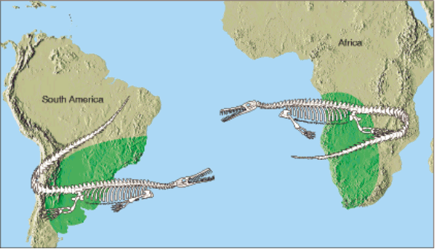
- Define the Theory of Plate Tectonics:
The idea that the lithosphere is broken into pieces called tectonic plates
- What are two pieces of evidence that support the theory of plate tectonics?
Fossils and mountain ranges; same climate conditions
- Circle the correct answers, increases or decreases: As depth increases / decreases density, temperature, and pressure increases / decreases.

- What is the difference between the physical and chemical layers of Earth?
Chemical: sorted by kinds of chemicals and amounts
Physical: sorted by physical traits (solid, liquid, rigid)
- What are similarities and differences between the crust and the lithosphere?
Crust: upper most rigid layer; chemical
Lithosphere: upper most rigid; physical
- Describe Asthenosphere. Describe the Mesosphere.
Asthenosphere | Mesosphere
Plastic Rock | Middle Layer; Largest Layer
Consists of Mantle | Consists of Mantle
250 km | 2,550 km

- What causes the tectonic plates to move? Describe how that process works.
Convection Currents in upper asthenosphere/mantle. Convection- warm; less dense matter rises.
- What is the difference between oceanic crust and continental crust?
Oceanic: under oceans, thinner, more dense
Continental: under continents; thick; less dense
- Compare and Contrast the Inner and Outer Core.
Inner core: Solid, denser, hotter
Outer Core: liquid, less dense, cooler

Name of layer -> | Inner Core | Outer Core | Mantle | Crust
Temperature | 4,000-5,000 ºC | 3,000-4,000 ºC | __1,000-3,000_________ºC | 0-1,000 ºC
Density | Densest | 2nd most dense | 2nd least dense | Least Dense
Composition | Iron and Nickel | Iron and nickel | Magnesium, Aluminum, Sodium | Aluminum; Sodium; Oxygen
Physical Properties | Solid | Liquid | Semi-solid molten rock | Rigid
Thickness | km | 2,200 km | km | 5-70 km

Free Space Below! - Write or draw anything else you remember about Earth’s Layers, Continental Drift, or Tectonic Plate!

