Condensation
- When water vapor cools and forms liquid water
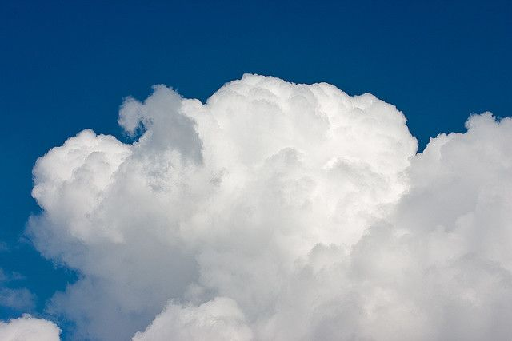
- You breathe your hot breath onto a mirror to fog it up
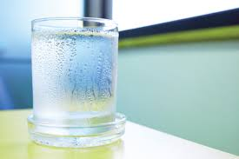

Precipitation
- It rains for 3 days straight in the Amazon Rainforest
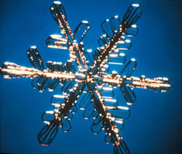
- When gravity acts on liquid water, pulling it down to Earth’s surface
Sublimation
- Dry Ice
- When solid water changes to water vapor without passing through the liquid stage 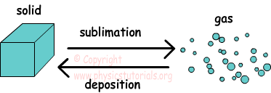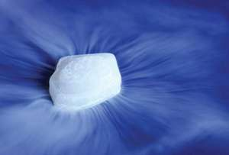
Runoff
- Snow melts on top of a mountain and flows downhill to join a river
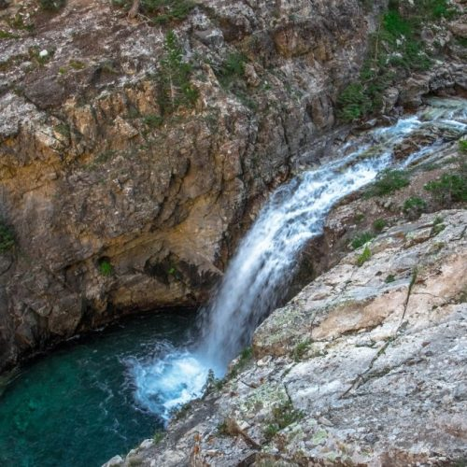
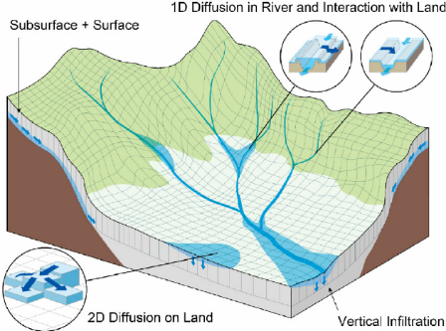
- When water flows over Earth’s surface from higher areas to lower areas
Infiltration
- When water seeps into Earth’s surface through gravity
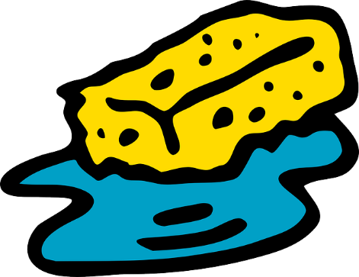
- Polluted water runs down a road and soaks into the land around it
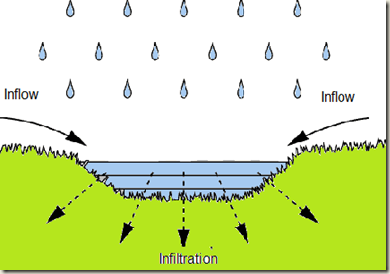
Evaporation
- When water changes from liquid water to water vapor
- The steam from a pot of boiling water
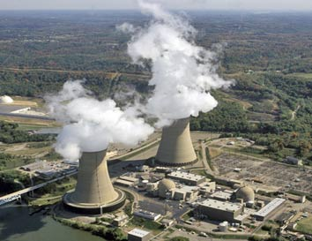
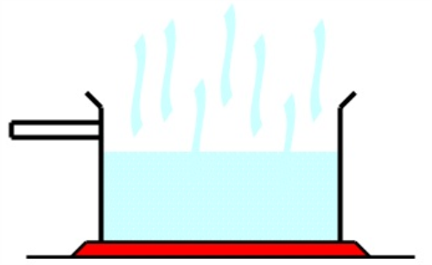

Transpiration
- When plants convert water to water vapor and releases the water paper from its stomata
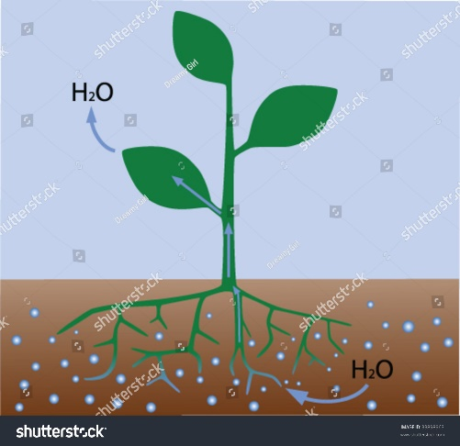
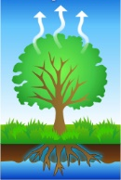
- A tree releases extra water vapor into the air around it
Collection
- A lake or ocean
- When water accumulates in a particular area
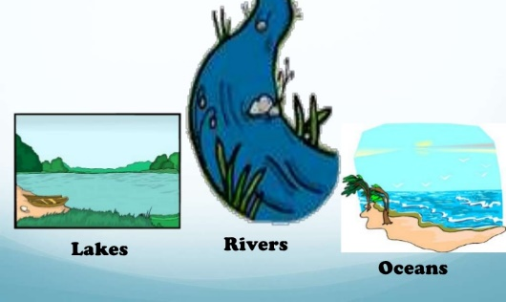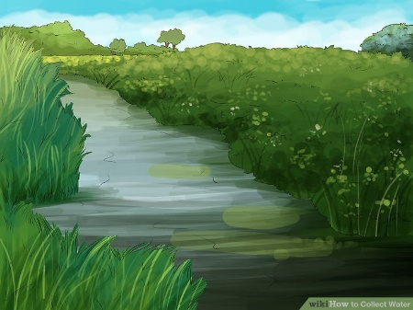
Solar Energy
- The driving force of the water cycle
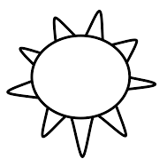
- The Sun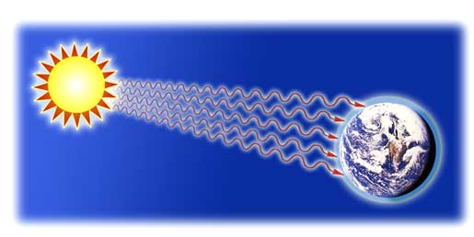

Groundwater
- Water that has collected underground
- Water in a well