Introduction:
As we’ve learned already, a meteorologist is someone who studies the science behind the weather, and uses that understanding to try and predict what weather is coming up (forecasting). Without trained meteorologists, there is not weather forecasting. Who depends on the weather forecast? Well, not just you and me when we get up in the morning – without accurate forecasts there would be big problems for agriculture, power plants, tourism, air, sea and road travel, and environmental management. Big storms such as hurricanes and tornadoes can cause death and destruction, and lives are saved by accurate forecasts.
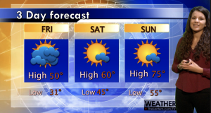
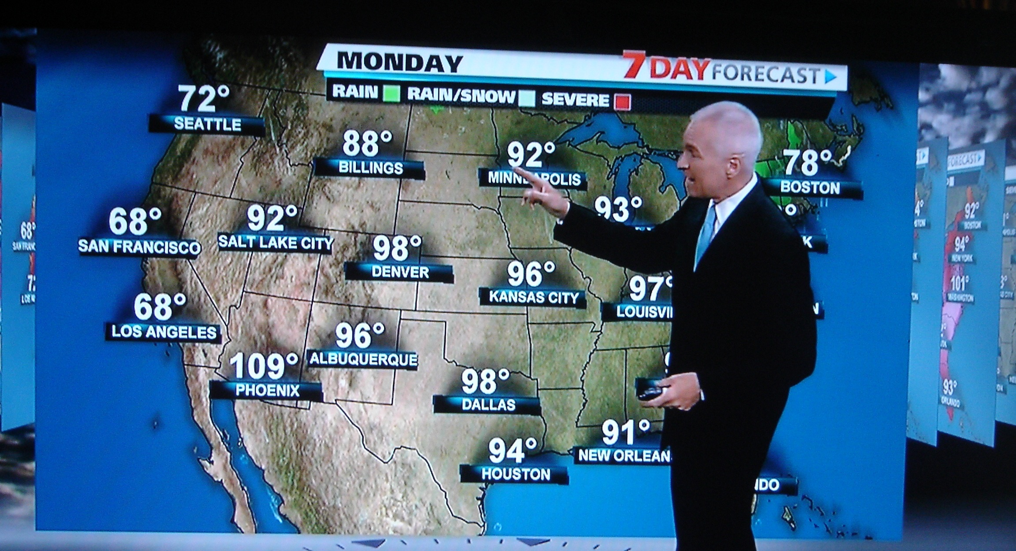

The task: You will work with another person to research and provide scientific knowledge explaining how air masses and fronts affect the weather.
Forecast: Each person on your team will present one of the following. (For template and guidance, use the Reading a Map homework and Air Mass Notes / Graphic Organizer).
- Personal introduction
- Explain 2 air mass, where it originated, and the characteristics of the air it brings.
- City / area (Example: Midwest USA, Northern Florida, Chicago, NYC) and temperature
- Explain 1 front where two air masses collide
  - Weather that is a product of the fronts
  - Correct symbol representation of the front
  - Correct movement of the front
- Include at least 8 vocabulary words

Cold Front | Occluded Front | Continental Tropical | Maritime Tropical | Air Masses
Warm Front | Stationary Front | Continental Polar | Maritime Polar | High pressure
Low pressure | Density | Temperature | Source Region | Movement
Moisture Content | Rises | Rain | Overcast | Cloudy / Clear

Presentation: Make sure you have good presentation skills. This includes: eye contact, good body language, and proper visual aids. You also need clear and audible voice.
Don’t forget to double check the rubric….

