Introduction:
As we’ve learned already, a meteorologist is someone who studies the science behind the weather, and uses that understanding to try and predict what weather is coming up (forecasting). Without trained meteorologists, there is no weather forecasting. Who depends on the weather forecast? Well, not just you and me when we get up in the morning – without accurate forecasts there would be big problems for agriculture, power plants, tourism, air, sea and road travel, and environmental management. Big storms such as hurricanes and tornadoes can cause death and destruction, and lives are saved by accurate forecasts.
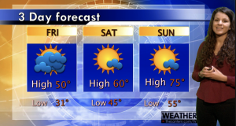
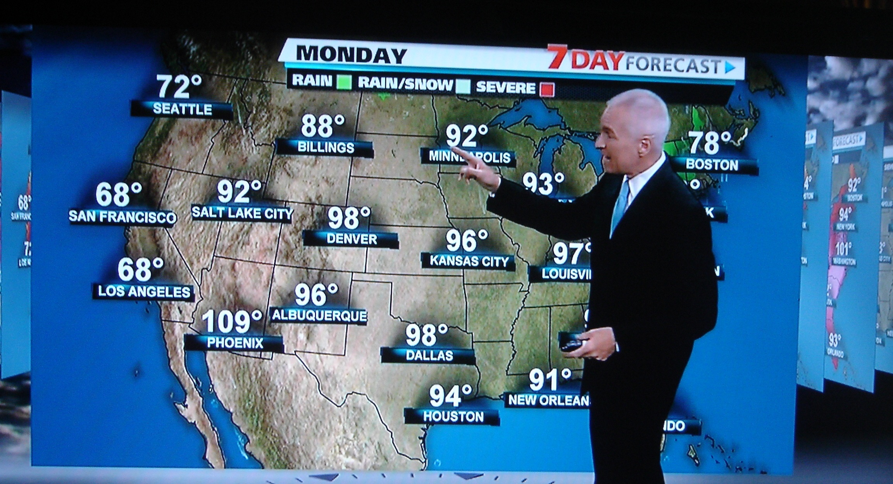

The task: You will work with another person to research and provide scientific knowledge explaining how air masses and fronts affect the weather.
Forecast: Each person on your team will present one of the following. (For guidance use your work book, and air masses and fronts handout).
Presenter 1 | Presenter 2
- Personal introduction  - Explain 2 air masses, where they originated, and the characteristics of the air it brings.  - Explain and describe the weather the fronts brings and the conditions that will follow.  - City / area (Example: Midwest USA, Northern Florida, Chicago, NYC) and temperature  - Explain 1 front where two air masses collide  - Weather that is a product of the fronts  - Correct symbol representation of the front  - Correct movement of the front | - Personal introduction  - Explain 2 air masses, where they originated, and the characteristics of the air it brings.  - Explain and describe the weather the fronts brings and the conditions that will follow.  - City / area (Example: Midwest USA, Northern Florida, Chicago, NYC) and temperature  - Explain 1 front where two air masses collide  - Weather that is a product of the fronts  - Correct symbol representation of the front  - Correct movement of the front

Include at least 8 vocabulary words
Cold Front | Occluded Front | Continental Tropical | Maritime Tropical | Air Masses
Warm Front | Stationary Front | Continental Polar | Maritime Polar | High pressure
Low pressure | Density | Temperature | Source Region | Movement
Moisture Content | Rises | Rain | Overcast | Cloudy / Clear

Presentation: Make sure you have good presentation skills. This includes: eye contact, good body language, and proper visual aids. You also need clear and audible voice.
Don’t forget to double check the rubric….
CATEGORY | 4 | 3 | 2 | 1
Presentation of forecast | Both participants introduce themselves and have equal participation in presentation. | One participants introduce themselves. Both participants have equal participation in presentation. | One participants introduce themselves. One participant carries the majority of the presentation. | Incomplete introduction or it is skipped altogether.
Air Masses | Four air masses are explained including where they originated, and the characteristics of the air it brings. | Three air masses are explained including where they originated, and the characteristics of the air it brings. | Two air masses are explained including where they originated, and the characteristics of the air it brings. | One air mass is explained including where they originated, and the characteristics of the air it brings.
Fronts | Two fronts are explained and described including the weather the fronts brings and the conditions that will follow. | Two fronts are partially explained and described including the weather the fronts brings and the conditions that will follow. | One front is explained and described including the weather the fronts brings and the conditions that will follow. | Fronts are not explained or described.
Movement of Fronts | Correct symbols for 2 fronts are used and moved correctly. | Correct symbols for 1 front is used and moved correctly. | Correct symbols for 2 fronts are used but moved incorrectly. | Correct symbols for 1 front is used but moved incorrectly.
Vocabulary | At least 8 vocabulary words are used in correct context. | Seven - 6 vocabulary words are used in correct context. | Five – 4 vocabulary words are used in correct context. | Three or less vocabulary words are used in correct context.
Posture and Eye Contact | Stands or sits up straight and look confident and relaxed. Establishes eye contact with audience during most of newscast. | Stands or sits up straight. Establishes eye contact with audience during most of newscast. | Slouches or appears too casual but establishes eye contact with audience during most of newscast. | Slouches or appears too casual AND establishes little eye contact with audience during most of newscast.
Speaks Clearly | Speaks clearly and distinctly all (100-95%) the time, and mispronounces no words. | Speaks clearly and distinctly all (100-95%) the time, but mispronounces no more than one word. | Speaks clearly and distinctly all (94-85%) the time, but mispronounces no more than one words. | Often mumbles or cannot be understood or mispronounces more than one word

Cold Front | Occluded Front | Continental Tropical | Maritime Tropical | Air Masses
Warm Front | Stationary Front | Continental Polar | Maritime Polar | High pressure
Low pressure | Density | Temperature | Source Region | Movement
Moisture Content | Rises | Rain | Overcast | Cloudy / Clear

