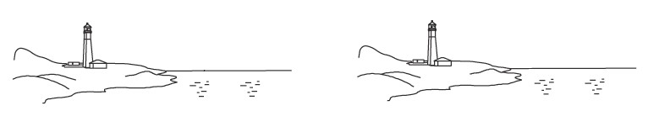
81 °
65 °
95 °
78 °

Wind Movement Name Date Period

Use the diagrams below to draw and label illustrations of wind movement. Your drawing should include: Low Pressure (L), High Pressure (H), Cool, Warm, and arrows showing the direction of wind movement.
81 °
95 °
78 °
65 °

Wind Movement Name Date Period

Use the diagrams below to draw and label illustrations of wind movement. Your drawing should include: Low Pressure (L), High Pressure (H), Cool, Warm, and arrows showing the direction of wind movement.

95 °
81 °
78 °
65 °
93 °
72 °
85 °
78 °

___________________________ Breeze __________________________ Breeze

Wind Movement Name Date Period

Use the diagrams below to draw and label illustrations of wind movement. Your drawing should include: Low Pressure (L), High Pressure (H), Cool, Warm, and arrows showing the direction of wind movement.
93 °
72 °
85 °
78 °

___________________________ Breeze __________________________ Breeze

Wind Movement Name Date Period

Use the diagrams below to draw and label illustrations of wind movement. Your drawing should include: Low Pressure (L), High Pressure (H), Cool, Warm, and arrows showing the direction of wind movement.
93 °
72 °
85 °
78 °

___________________________ Breeze __________________________ Breeze

