Wind Test Study Guide
1. _____________ are the winds that blow from the poles to 60° latitude in both hemispheres and from east to west.

2. Land/sand heats and cool ____________, whereas water heats and cools _____________.
Describe the following winds:
3. Polar Easterlies _________________________________________________
4. Prevailing Westerlies _________________________________________________
5. Trade Winds _______________________________________________________

Describe and illustrate the following methods of heat transfer:
6. Heating of molecules causes matter to ____________________.
Illustration
7. Convection _______________________________________
Examples: _________________________________________

8. Conduction _______________________________________
Illustration

Examples: _________________________________________

9. Radiation ________________________________________
Illustration

Examples: _________________________________________

10. Wind and air pressure is caused by:
Wind is caused by ________________________ in air pressure
Air moves from ____________ _____________ to ____________ ____________
Air pressure is caused by _______________________________________________
What causes uneven heating of Earth? _____________________________________
Which heats and cools faster (land or water)? _______________________________
Why? ______________________________________________________________
Density:
______________
Temperature:
______________
Air
Density:
______________
Temperature:
______________
Pressure Air
Pressure

11. The Coriolis Effect causes the winds to move in a ______________ path do to the Earth’s ______________________________.
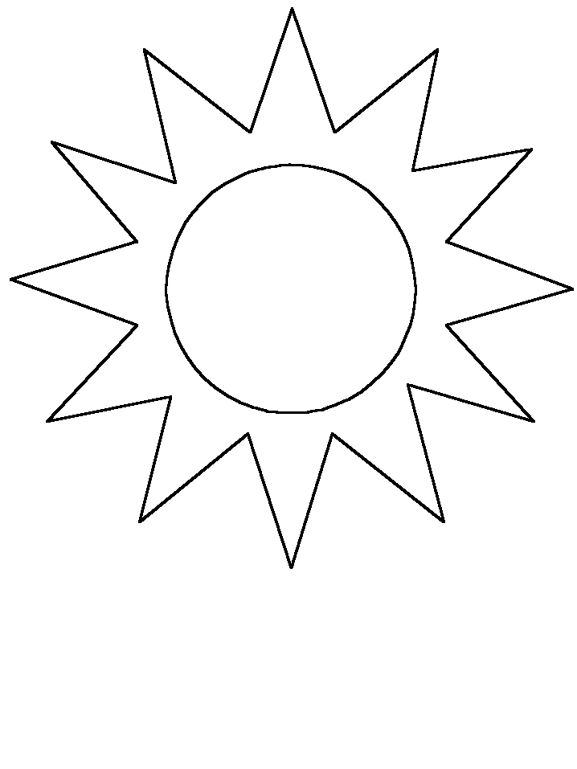

12. Label the drawing indicating day time.
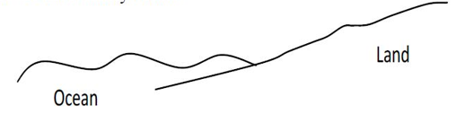
Include: L or H pressure
Direction of wind
Name of local wind.

13. Label the drawing indicating night time.
Include: L or H pressure
Direction of wind
Name of local wind.

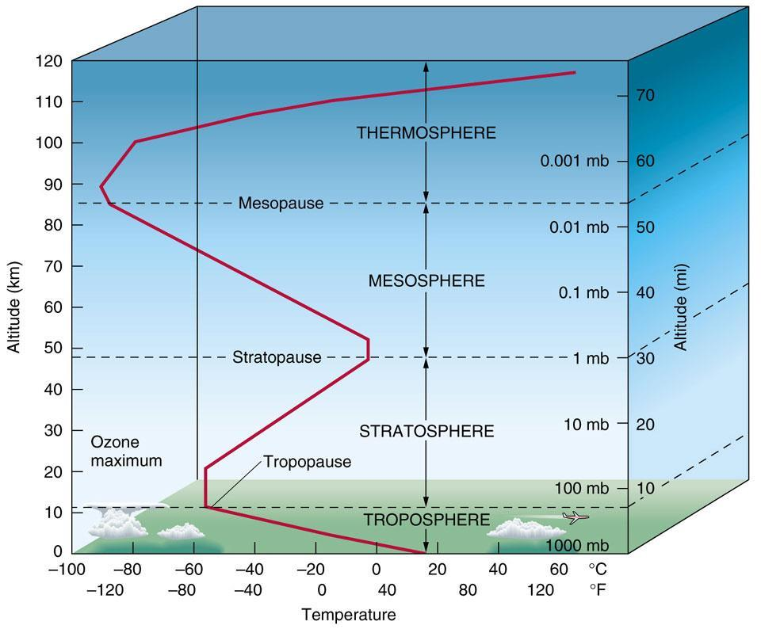

14. Atmosphere:
Label the layers of the atmospheric layers.

What does the diagonal line indicate?______________

Which layer holds the most mass? ___________________

Why is the Ozone important? _______________________

