Winds
Wind is the horizontal movement of air from an area of high pressure to an area of lower pressure. All winds are caused by differences in air pressure. Most differences in air pressure are caused by unequal heating of the atmosphere. Cool, dense air has higher air pressure so it flows underneath warm, less dense air, forcing the warm air to rise.
Winds are described by their direction and speed. Wind direction is determined with a wind vane. The name of a wind is the direction the wind is coming from. Wind speed is measured with an anemometer. Wind blowing over your skin removes body heat. The increased cooling that wind can cause is called the wind-chill factor.
Local winds are winds that blow over short distances. Local winds are caused by unequal heating of Earth’s surface within a small area. Local winds form only when no winds are blowing from farther away. The sun heats land faster than water, so during the day air over land becomes warmer than air over water. The cool air blows inland from the water and moves underneath the warm air. The flow of air from an ocean or lake to the land is called a sea breeze or a lake breeze. At night, land cools more quickly than water, so air over land becomes cooler than air over water. The cool air blows toward the water from the land and moves underneath the warm air. The flow of air from land to a body of water is called a land breeze. Sea and land breezes over a large region that change direction with the seasons are called monsoons.
Winds that blow steadily from specific directions over long distances are called global winds. Warm air rises at the equator and cold air sinks at the poles, causing winds at Earth’s surface to blow from the poles toward the equator. The movement of air between the equator and the poles produces global winds. Because Earth is rotating, global winds do not follow a straight path. The way Earth’s rotation makes winds curve is called the Coriolis effect. In the Northern Hemisphere, global winds curve to the right. In the Southern Hemisphere, global winds curve to the left.
The Coriolis effect and other factors produce a pattern of calm areas and wind belts around Earth. The calm areas are called the doldrums and horse latitudes. The major global wind belts are the trade winds, the prevailing westerlies, and the polar easterlies. Latitude is a measure of distance north and south of the equator. The trade winds blow between the equator and 30° north and south latitude, the prevailing westerlies between 30° and 60° north and south latitude, and the polar easterlies between 60° north and south latitude and the poles. About 10 km above Earth’s surface are bands of high speed-winds called jet streams. They blow from west to east.

Polar easterlies Prevailing westerlies Polar easterlies doldrums
horse latitudes
- Identify and Label the global winds in the figure below. Use the words in the word bank provided:

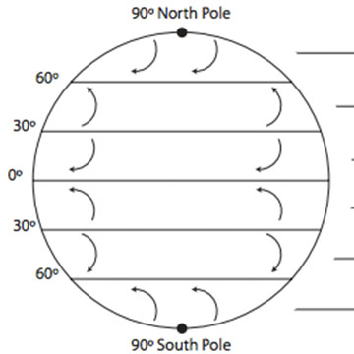
If the statement below is true, write TRUE. If it is false, change the underlined word to make it TRUE.
- _____________________ Wind is a horizontal movement of air from an area of high pressure to an area of lower pressure.

- _____________________ Wind speed is measured with a(n) wind vane.

- _____________________ The increased cooling that wind can cause is called the Coriolis effect.

- _____________________ Local winds are winds that blow over short distances.

- _____________________ The flow of air from an ocean or lake to the land is called a land breeze.

- ______________________The flow of air from land to a body of water is called a sea breeze.

- ______________________Winds that blow steadily from specific directions over long distances are called doldrums.

- _______________________ The way Earth’s rotation makes wind curve is called the prevailing westerlies.

- _______________________ Bands of high-speed winds about 10 km above Earth’s surface are called polar easterlies.

Short Response: Answer the following questions below in complete sentences:

- Explain the difference between global and local winds.

- Would there be winds if the Earth’s surface were the same temperatures everywhere? Why or why not?

- Why does warm air rise and cold air sink? Which is a low pressure area and which is a high pressure area?

